## **Updated Gantt Chart**

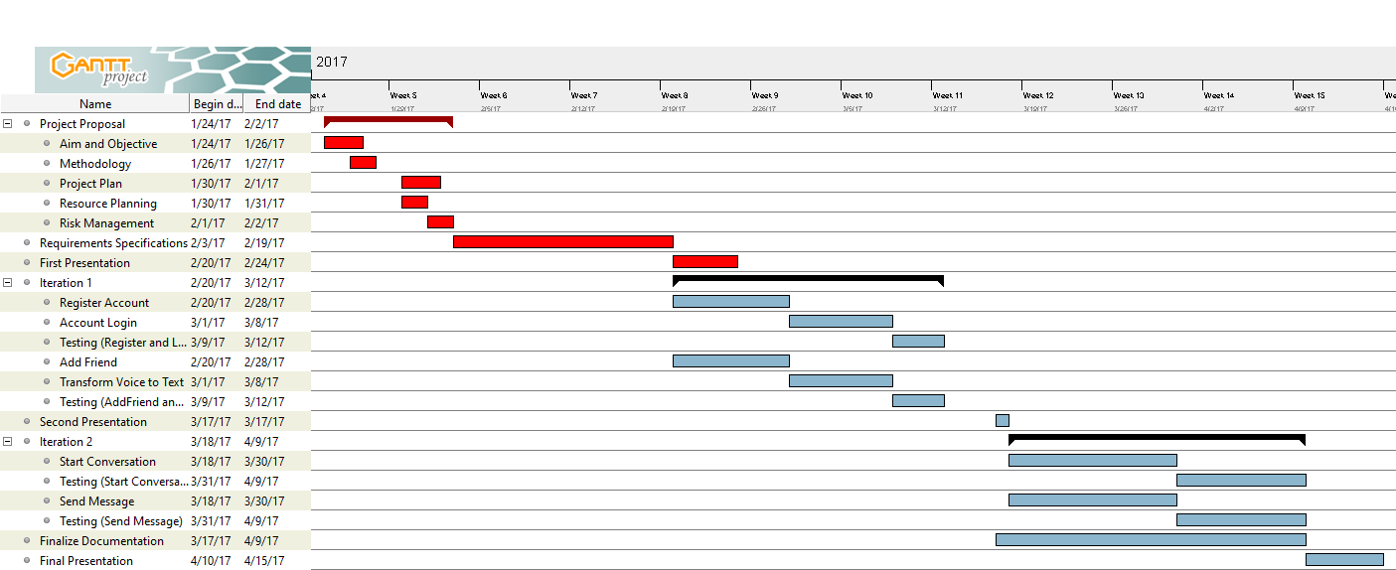

## **Description of any testing tools**

We are not using any third party testing tools. We just search for solution on internet and fix it ourselves and we do have emulator and smartphone in our testing progress which is Android Studio built-in emulator and our own android smartphone. For both of them, we use for testing our function and debugs.